

|  |
| --- |
| **Implementing improved methods of Patient care using IoT, Mobile Devices and Website Applications**  Aaron Stones  BSc Computing with Honours, 2020 |

|  |
| --- |
| School of Design and Informatics  Abertay University |

Contents

Table of Tables iv

Acknowledgements v

Abstract vi

Abbreviations, Symbols and Notation vii

Chapter 1 – Introduction 1

Chapter 2 – Literature Review 2

2.1 Introduction 2

2.2 NHS and Data Collection 3

2.3 IoT (in general) 4

2.4 Something about mobile applications and their benefit 6

2.5 Summary 7

Chapter 3 – Methodology 8

3.1 Project Overview 8

3.2 Analysis 9

Aims & Objectives 9

Functional & Non-Functional Requirements 11

Further Analysis 12

3.3 Design 13

3.4 Implementation 16

Mobile Application 16

Website Application 17

IoT device 17

3.5 Evaluation 18

Chapter 4 – Results 19

Chapter 5 – Discussion 19

Chapter 6 – Conclusions & Future Work 19

List of References 20

Bibliography 21

Appendices 22

Table of Figures

# Table of Tables

# Acknowledgements

# Abstract

300 words

Usually read first by the reader

Write this last

Summarise what you did, results and conclusions

Not an intro so no references

# Abbreviations, Symbols and Notation

If required

# Chapter 1 – Introduction

**750 – 800 words + 133 words per section**

**Set the scene**

**Background to and purpose of the investigation**

**Scope**

**Project aims/research questions**

**Likely to be more focussed than the proposal**

**End with an overview of the remaining chapters**

Within the United Kingdom right now it is estimated that around 410,000 people live inside ‘Care Homes’ (GOV.UK, 2019). Around 10% of these residents have primary health options, this means the patient is no longer able to look after themselves and have been admitted to residential care to protect them. A following 49% of the residents in ‘Care Homes’ are LA-funded, this is a scheme setup by the United Kingdom government to contribute to a quarter of the living costs for these residents (GOV.UK, 2019).

However, it has been reported within the media recently that due to an ever increasing and ageing population, a need for patients to be admitted due to concerns for their health (primary options) out-ways the need for these forms of care. This is in comparison to residents on LA-funded schemes, who could achieve an equally adequate or even better form of care from their own homes through the use of technology. This technology could be used to manage the different conditions patients may have or used to detect these conditions early.

Within these ‘Care Homes’ many patients are living with both; early and advanced neurological brain conditions and require regular assessment from Nurses and Doctors to assess the progression of their disease and any notable changes. This only happens if a patient has been correctly diagnosed. If Parkinson’s is taken as an example according to WebMD – “It has been estimated that, especially in its early stages, nearly 40% of people with Parkinson’s Disease may not be diagnosed, and as many as 25% are misdiagnosed.” (WebMD, 2019) This shows a lack of ability to accurately detect this conditions and so accurate care cannot be provided. The main means for the detection of degrading neurological conditions is the use of CT scans, which are both time consuming and expensive to public bodies like the NHS (National Health Service), with each scan costing around 609.70 pounds according to costevaluation.com (Costevaluation.com, 2019). This is a necessity to accurately detect neurological conditions but are in high demand. Mobile Phones and IoT devices could be used to run small tests before hand by the suspected sufferers to give an early prognosis of these conditions where then the CT scan is only a formality to confirm what is already known.

# Chapter 2 – Literature Review

## 2.1 Introduction

This chapter investigates the previous work that has been proposed to ensure both effective care is given to patients and new forms of technology that could be employed to manage this effective care. The purpose of this chapter is to consider the key findings of existing literature in this area and how this thesis will build upon/ contribute to this area.

Former studies have considered the way in which readings have been taken from patients and how these readings are; stored, processed, analysed and displayed to medical professionals. Many of the methods that are used to collect data from patients have not been updated for decades. For example, in a study exploring the reliability of clinical systems in the UK NHS, author (year) argued that “Reported reliability was low for the four systems studied, with some common factors behind each. However, this hides significant variation between organisations for some processes, suggesting that some organisations have managed to create more reliable systems. Standardisation of processes would be expected to have significant benefit.” This highlights that a lack of consistency between organisations is present and the need for consistency to be able to effectively manage, care, medicines and management of services (Burnett S, Franklin BD, Moorthy K, et al, 2012).

When measuring a person’s health much of the process involves medical supervision, largely through simple readings such as heart rate, temperature, weight and blood pressure. Most of the readings can be taken through new technologies such as smart phones and internet of things devices. Smart phones, in particular, contain many built in sensors which can take a plentiful supply of readings from patients without the need of a medical professional to be present.These tests could be extended and upgraded to provide extra care for patients suffering with degenerative mental health conditions, using the previously mentioned sensors within IoT devices and smart phones.

Therefore, the three main areas that are being targeted are the NH and data collection within the NHS and the basics about IoT devices and smart phones.

## 2.2 NHS and Data Collection

To take basic readings, a patient is either required to visit their local hospital for an appointment with a Nurse/Doctor, or if they are incapable due to disability or old age, a District Nurse would be sent out to retrieve the readings. Possibly, a patient could wait for hours for these simple readings to be taken and for advice to be given to the patient. In the case of patients suffering from Parkinson’s disease, such individuals have limited means of managing this disease independently, both medically and within their lifestyle. After diagnoses, the patient receives monthly assessments with a Doctor or a specialised Nurse, in which their tremors are assessed visually and their concerns are discussed. Following from such appointments, patients are sent home with an action plan and an appointment for the following month. However, according to the Patient website, a person with Parkinson’s should receive; Parkinson's disease nurse specialists, Physiotherapy and physical activity, Occupational therapy, Speech and language therapy and Nutritional support (Tidy, 2020). Within the United Kingdom due to shortages within the NHS, the amount of recommended care for a single patient cannot be provided to every sufferer of Parkinson’s. This means that only a Doctor’s appointment or a specialised Nurse can see a patient each month, they report whether further action is needed or if the patient is fine. If a patient requires an extra appointment for any reason, they are required to visit their local General Practitioner.

This disequilibrium between the needs of patients and the resources available suggests a need for change in the ways in which this disease and other diseases are managed. “Evidence suggests that such changes should focus upon the freeing up of resources to ensure each patient is receiving an adequate level of care and that the data collected from patients is increased in order to provide a better understanding of whether each patient’s condition is degrading or improving (back up with references. This would also prevent unnecessary hospitalisations because a more comprehensive view of a patient’s health has been gathered and a better understanding of their health has been gained. Within the clinical investigation ‘Residents: Frequency, Causes, and Costs’ it is suggested that the unnecessary hospitalisation of patients is likely to cause their health more issues due to the stress of being transferred to a hospital. The study then goes onto state that 67% of hospitalisations are avoidable and take up a great deal of NHS resources. These resources could be better utilised if it is found out that a patient did not need hospitalised. This also works if the patient takes a reading that a medical professional does not like, and a life is saved because they were hospitalised with a serious condition.

(This makes the case for using technology rather than medical time well. You could be more provocative and add some political aspects to this; NHS under pressure, no hope of the funding to cover all these patients, bed blocking)

## 2.3 Micro-Processors

Previously mentioned devices can be used to take several readings and send them to a server. One of these are IoT devices, or internet of things devices, these are microprocessors that transfer data over a network to a cloud server without the need for Human-Computer or Computer-Human interaction. They carry a relatively low amount of processing power, RAM and are mainly used for the sending of data. The fact they have low system performance means that they are very inexpensive pieces of technology and are simple to setup and utilise. Within the United Kingdom they have been used for devices like the Nest Thermostat – a device that is programmable and self-learning device that optimises the heating and cooling of homes, Berennis Smart Light Bulb – allows a user to change the colour and brightness of the light through an application on their phone, Sense Energy Monitor – a device that is installed into a home’s electrical panel to provide insight into energy usage within that home through the use of mobile and web applications (Mishra, 2020). These devices can send and receive data from a server, the server usually acts on data based upon a user entering an input or a sudden change in the data being received by the server. These technologies (as can be seen from the previous examples) can be programmed and have sensors added to them to provide different functionality for the user and send different kinds of data to a server.

If this technology is applied in a medical sense, the NHS has put IoT devices through a rigorous testing phase: “As part of an initiative to set up testbeds to pilot new technologies in the health service, NHS England and the Department of Health has awarded £10m in funding to two 'test bed' projects that it describes as "IoT-led".” (Best, 2020). One of these projects is called, TIHM or Technology Integrated Health Management. This system is used to monitor patients with Dementia, reduce the need for hospital admissions and relieve the stress on carers (Sabp.nhs.uk. (2020)). The devices used are IoT devices, they send a signal to clinicians when they detect an issue with the patient such as falls, turning on things they shouldn’t and long-term periods of idleness.

The functionality of an IoT device is simplistic: local sensors or data gathering instruments pass data onto, or are built directly onto the IoT device. From this these readings are either sent to a platform or a different cloud platform, from which, the data could either be stored within a database, like what is shown in the diagram below, or processed directly on the cloud platform. This could then move onto a third stage of informing a user about a change in the data stored within the database or directly send notifications from the cloud platform to a user’s mobile application, directly to their smart phone, or the data that is being presented within a website application.

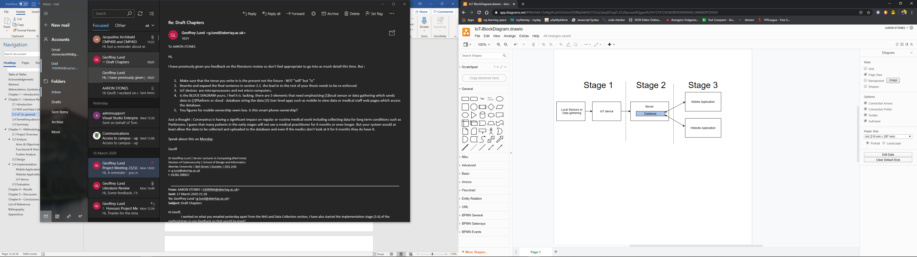

## 2.4 Mobile Applications

As well as IoT devices, a further device that can be used in this context and has a quantity of highly sensitive sensors, are Smart Phones. These have the advantage over IoT devices, that they are widely used and most of the U.K has a mobile phone, the age group with the lowest percentage of mobile phones is 55 and over. This age bracket has a percentage ownership of 55%. All other age groups above the age of 16 have an ownership greater than 90% (O'Dea, 2019). Most Smart Phones within the U.K have the ability to communicate with a web server from almost everywhere with the use of Mobile Data and Wi-Fi in U.K homes, this allows for convenience when a User is required to send or receive data from a server. Receiving data anywhere, allows a User to keep up to date with any changes within the server, due to new data being entered or data needing to be entered. Examples of this have been used within rural countries within Africa, the technology is called tele diagnosis and it is used for patients to communicate with Doctors by sending them photos, information about their ailments and a Doctor can send different courses of action or treatments. The technology has been widely successful due to the instantaneous nature of Mobile Phones and the quality of the cameras, microphones to help a medical professional make an informed decision on the best course of action this is usually done through the iSAT solution, to use highly qualified urban doctors to provide medical aid from a distance (User, 2020).

As previously mentioned, the quality of the sensors within mobile phones are incredibly sensitive and can detect the smallest changes in movement, heat. sensors have been increasing in quality since 2014. GPS or Global Positioning System also allows people to pinpoint their locations and track their movements, whether that be for fitness, or for their own personal safety. GPS has been used to track elderly people with degenerative brain conditions such as Dementia to plot a circle as to an area where they are meant to be. If a Dementia sufferer travels outside of the circle set out by a program, a signal is sent to a server and a next of kin, carer or medical professional are contacted to check on the safety of the patient called geofencing. This means if a Dementia sufferer gets confused and lost, the carer can locate them and bring them back home. Furthermore, mobile applications can communicate with servers which allows for further communication between a web page and a smart phone. This permits users to manage data entered onto a mobile application and user data or content within the application. This also works to provide a failsafe is a user forgets their login data.

## 2.5 Summary

This literature review has analysed trends and common practices of technologies used both within and out with the NHS. With what has been discovered through the research conducted, IoT, smart phones, website applications and a server could be used to implement an effective technology for the management of elderly patient’s health. This management system could cut down on the time spent by medical professionals within the NHS from taking simple readings from patients. This could also improve the management of patients using Databases to store results from patients and report back to medical professionals (in graphical format), if a patient looks to be improving or degrading in their health or their condition.

# Chapter 3 – Methodology

Within this Methodology chapter, an explanation of the processes involved in the development of this project is be given. As well as, the justification for these processes. Techniques such as System Diagrams, Test-Driven Development, Surveys and qualitative Interviews are discussed to show exactly how this project was birthed. The project followed a somewhat Waterfall development process, following the classic, Analysis, Design, Implementation, Testing and Evaluation steps. However, the way in which changes and suggestions were implemented have been handled in an Agile format. This allowed the developer to cope with these changes easier and track the progress of the project with greater ease.

## 3.1 Project Overview

In Lehman’s terms, this project looks to build a system that tracks different health measures of a patient. These measurements include, heart rate, blood pressure, body mass and patient temperature. These measures are be coupled with the hand shaking test developed as well. These measures are sent to a server where they are stored and presented to medical professionals in graphical format, this allows the medical professionals to gain a better idea of patient degradation or improvement. The readings are taken by sensors on a mobile phone, such as the accelerometer for measuring the intensity of handshakes, for patients with Parkinson’s. A simple memory game to plot a value for the patient’s wellbeing in terms of the detection and monitoring of Dementia. These are all done on a mobile phone. Not everyone in the United Kingdom ha a mobile phone, so an IoT device is setup and uses a health kit to take simple measurements (this device cannot conduct the Dementia or Parkinson’s measurements). The medical professionals take all the data that has been posted to the server and allow medical professionals to select patients and see their results, while communicating advice to patients and send messages/advice to individual patients.

## 3.2 Analysis

As Initially stated, the first stage undertaken was an analysis of the subject. This involved; a meeting with the subject specialist to see if the project idea was feasible, the creation of Aims & Objectives, the production of Software Requirements and an analysis of the requirements of each piece of software.

### Aims & Objectives

|  |  |
| --- | --- |
| **Aim** | **Objectives** |
| Analyse the methods of which detection of incurable neurological disorders are carried out to utilise IoT and Mobile Devices, so a system can be developed that can be analyse and decide the best courses of action. | * Identify through interviews and research with medical professionals and literature what tests are used within the medical world to diagnose these issues. * Identify the methods used by medical professionals to monitor the progress of the disorder and provide effective care, to see if these can be or already have been digitised, and if so, can they be made more effective. * Analyse the data that has been collected, to develop a system to show graphs patients state either; bettering, deteriorating or stabilising. |
| Design an effective management system that incorporates all three technologies (Web App, Android Application and IoT device). | * Identify the system logic through the creation of a System Diagram. * Depict how the user data will be stored within the server through the creation of a Database Schematic * Create a diagram to show how each technology will be interconnected throughout the system. |
| Develop a system to manage the patients effectively with the three technologies. | * Review and select the best methods for measuring a patient’s vital signs on both IoT and Android Devices. * Replicate the systems in place where possible and create new Algorithms where none exist. * Analyse the best free to use Application Programming Interfaces to display a patient’s results in graphical format. |
| Analyse the effectiveness of the system as a whole and the communication between integral parts. | * Conduct System Testing to make sure the system as a whole works effectively. * Conduct Unit Testing between the server and three devices, this will depict whether communication is effective or not. |
| Create an effective test plan to ensure the system is operating as planned. Test plan must incorporate an ability to measure accessibility as this system is for Elderly patients. | * Follow Test-Driven development to ensure code is secure and best practices are followed. * Unit testing will be conducted on functions to ensure functions and components are working as expected. * Accessibility testing must be conducted to ensure the system can be used by all patients. |
| Test the effectiveness of the measurements taken on both IoT and Android Devices, also how the results are presented within the web app. | * Analyse the results based on the developer’s vital signs taken with reliable medical instruments. * Compare different graph API’s to select one with a line of best fit and that is free to use. |
| Evaluate the hypothesis of the project using Interviews and Surveys with medical professionals and the public. | * Assess the test subjects’ thoughts and opinions on the software using unstructured interviews. * Construct a following structured interview to gain data pertinent to evaluating solely the hypothesis. |

These Aims & Objectives have been set out to provide a clear direction of the project. They have also provided the basis for the development of the Functional and Non-Functional Requirements and will form the basis of testing to ensure either the aims and objectives have been met or have not.

### Functional & Non-Functional Requirements

|  |  |
| --- | --- |
| Functional Requirements | |
| FREQ ID | Requirement |
| FREQ001 | Users must be able to register an account |
| FREQ002 | Users must be able to login to an existing account |
| FREQ003 | Users must be able to view their account information |
| FREQ004 | Users must be able to modify their account information |
| FREQ005 | Users must be able to easily contact their Doctor |
| FREQ006 | Users must be able to perform a test on a mobile and an IoT device |
| FREQ007 | Users must be able to delete their accounts and remove all their data from the Database |
| FREQ008 | The user must have an option to enter in readings manually that cannot be taken off a phone or IoT device |
| FREQ009 | Users must be able to contact support |
| FREQ010 | Users must have a way of displaying readings in graphical format for review |
| FREQ011 | Users must be able to receive advice from all medical professionals based on their conditions |
| FREQ012 |  |
| Non-Functional Requirements | |
| NFREQ ID | Requirement |
| NFREQ001 | This application will be responsive, and users will therefore be able to operate it with ease on multiple types of devices including mobiles, tablets and computers. |
| NFREQ002 | This application will be reliable, this will allow users to operate it with a high degree of trust, knowing that it will work as they expect it to. |
| NFREQ003 | This application will be scalable as it will accommodate heavier loads and large number of users |
| NFREQ004 | This application will be maintainable by the developers, and any other teams that work on it due to its thorough documentation. |
| NFREQ005 | This application will use secure practices, as it will be fully compliant with the Data Protection Act, meaning we will store the data securely and for the correct amount of time. The team will comply with the General Data Protection Regulation. |
| NFREQ006 | This application will be user-friendly and accessible where possible to allow for those with disabilities to use the application to its full potential. |

As well as Functional & Non-Functional Requirements, many rules, regulations and standards must be followed throughout the development process. Some of these, have been set out by the I.E.E.E (Institute of Electrical and Electronics Engineers) or I.S.O (International Organisation for Standardisation). There are plenty of regulations set out by these organisations that the developer has followed these throughout the development phase. (www.tutorialspoint.com, 2018)

There are two main Laws that the developer respected and avoid breaking at all costs the first one is the Computer Misuse Act. The developer has set out strict rules as to what they should be able to be done with the produced software and is well informed of the risks of ‘hacking’ and leaving security issues within the code. These steps have been taken to ensure the team does not breach these laws.

Just as the utmost care must be taken for the Computer Misuse Act. The same due attention must be taken for the Data Protection Act. This Law must be respected, and user data must not be delegated to any unauthorised personnel. The developer has also developed the project with the utmost security to ensure that users will not have their data unlawfully distributed.

### Further Analysis

Within the initial meeting between the developer and the subject specialist, the idea was put forward and discussed as to whether it was feasible or not. The subject specialist agreed the project was feasible and thought and added insight into what would require the most work and what would require the least. This was highly beneficial to the developer as this gave valuable insight into the time scales for the developers Gantt Chart.

A review of the facilities at Abertay University had to be conducted to decide whether outside software needed to be utilised. This was not the case and Abertay University had all the necessary features required to develop the project. These were decided as A Website Application for the Medical Professionals to be able to monitor the patients. This uses technologies such as the LAMP (Linux Apache MySQL and PHP) stack, coupled with HTML (Hypertext Mark-up Language), JavaScript and CSS (Cascading Style Sheets). Following this, Android Studio was selected to develop the Mobile Application; firstly as Android devices are some of the most commonly used devices in the world, to develop on iOS for Apple devices a Virtual Machine would need to be used to run MacOS and this would be awkward and cause issues during testing because the developer only has access to an Android running phone, so could not accurately prove this concept.

## 3.3 Design

As previously hinted towards, these devices must work in tandem to show the results from each on the medical professional’s website application. So, to initially understand the logic of the system, a System Diagram was created to show the communications to and from the server and between devices. As shown below.

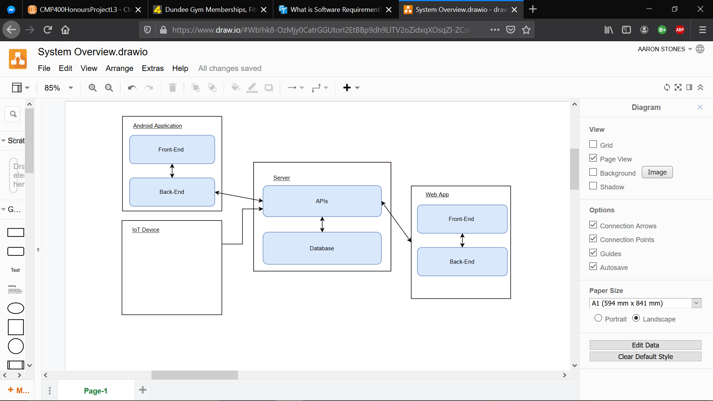

As shown above, all devices send and receive data to and from a centralised server. This allows all data to be kept within the same place and allows ease of access between devices and the data, using REST (Representational State Transfer) APIs (Application Programming Interfaces) within the server. Th server supports the backend programming language called php. Therefore, all REST APIs are coded within PHP. The REST APIs are contacted by multiple devices, for example, to record results as both the IoT device and Android device are recording most of the same results. This means that the same REST APIs can be used by multiple devices. A diagram has been created to show the communication between devices and the REST APIs.

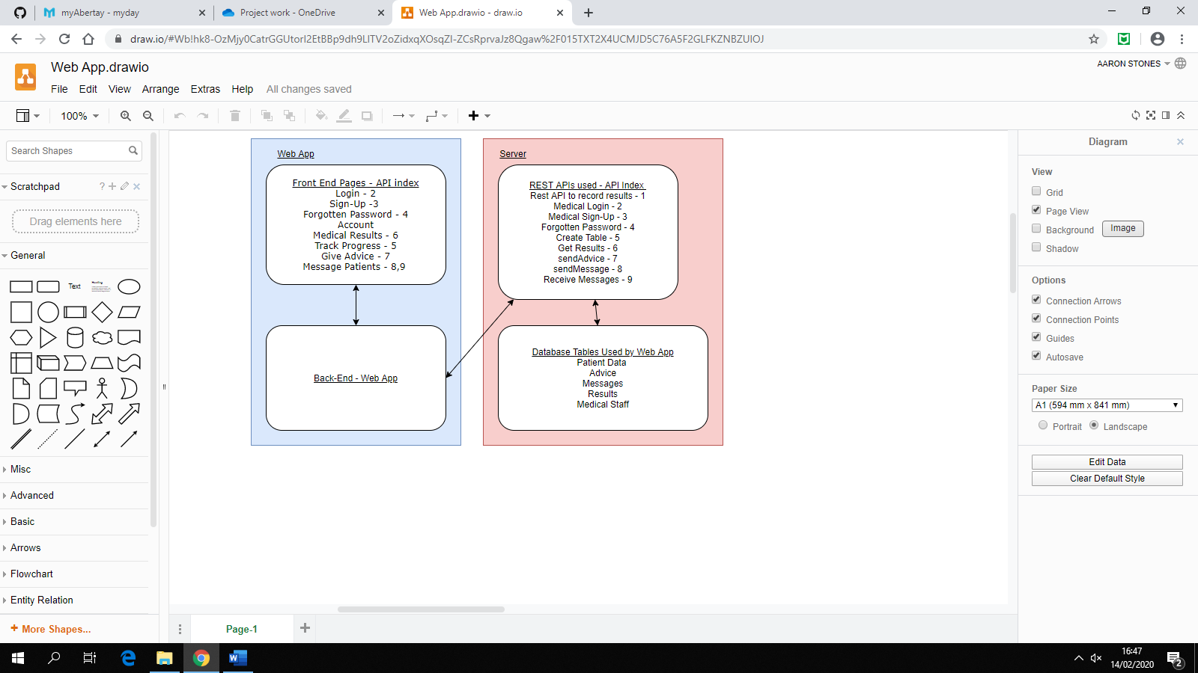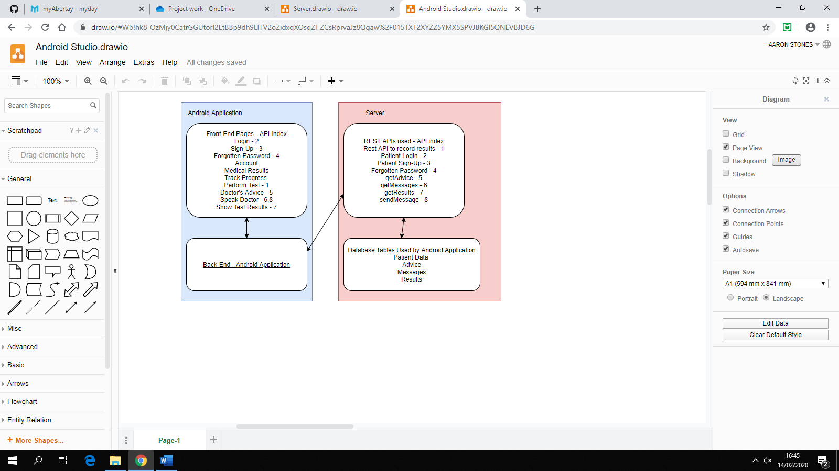

These APIs used will have to store the data in some place, the developer has decided the best place to store the data is a MySQL database. This has been selected because the type of data being stored is unlikely to change as the measurements being taken are standardised (Blood Pressure, Heart Rate, Blood Oxygen and Temperature). MySQL databases are perfect for data types that are unlikely to be changed and for amounts of types of data that are unlikely to change. So, for standardised measures of health that have been used for decades this type of database is perfect to use. Also, Abertay University provides a free to use database of this type. Relationships are the basis of MySQL databases and within this project there is no change within that. Relationships have been created to decrease the amount of repeated data within the Schema. A diagrammatical view of this has been created and can be seen below.

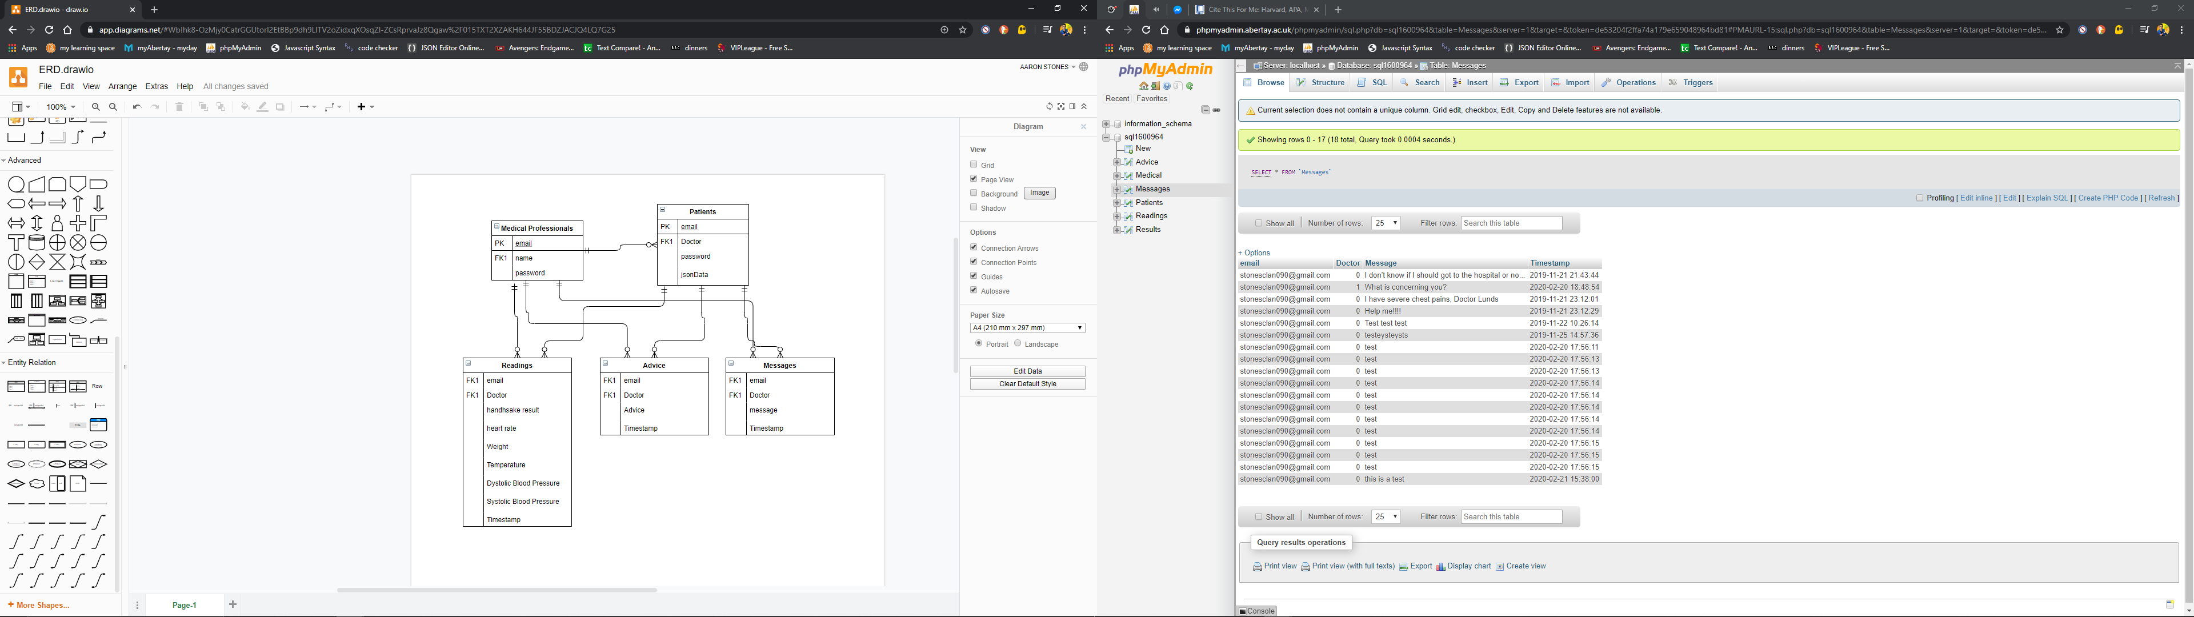

The REST APIs will be used to communicate with this database, to store things like medial professionals’ information, results, patient information. A further diagram has been created to show the relationship between these REST APIs and the Database within the server. As shown below.

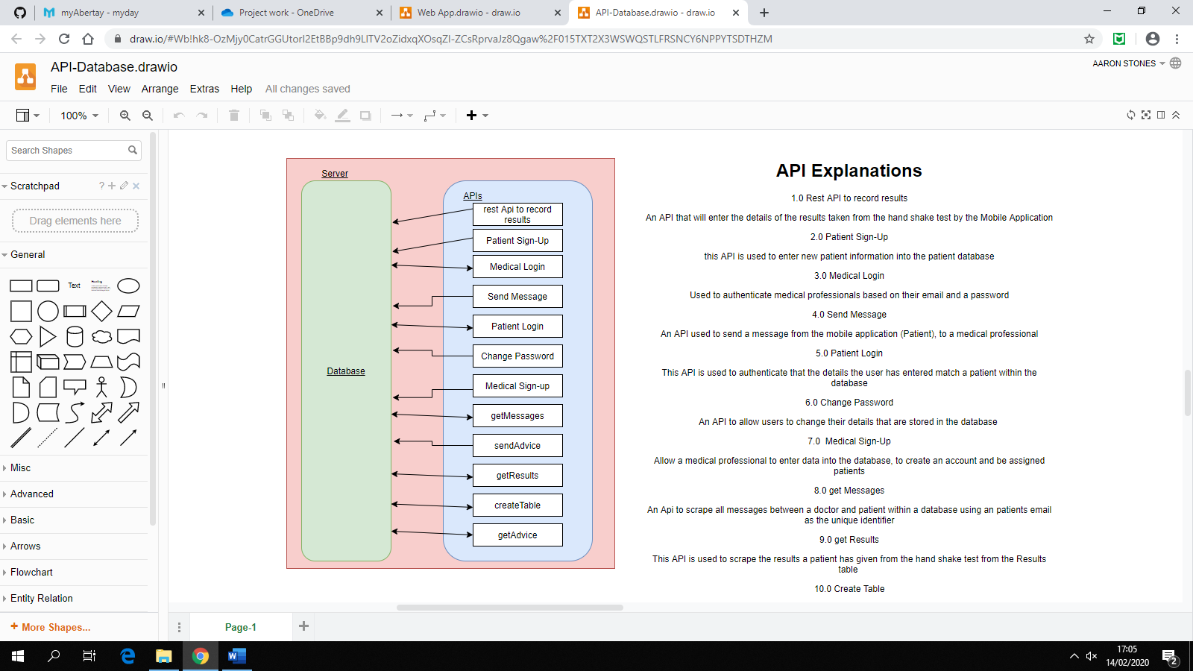**1.0 Rest API to record results -** An API that will enter the details of the results taken from the handshake test by the Mobile Application.

**2.0 Patient Sign-Up -** this API is used to enter new patient information into the patient database.

**3.0 Medical Login -** Used to authenticate medical professionals based on their email and a password.

**4.0 Send Message -** An API used to send a message from the mobile application (Patient), to a medical professional.

**5.0 Patient Login -** This API is used to authenticate that the details the user has entered match a patient within the database.

**6.0 Change Password -** An API to allow users to change their details that are stored in the database.

**7.0 Medical Sign-Up -** Allow a medical professional to enter data into the database, to create an account and be assigned patients.

**8.0 get Messages -** An API to scrape all messages between a doctor and patient within a database using a patient email as the unique identifier.

**9.0 get Results -** This API is used to scrape the results a patient has given from the handshake test from the Results table.

**10.0 Create Table -** This creates the php table to show a medical professional the progress of a patient, based on their results stored within the results table.

**11.0 get Advice -** Gets the advice from the advice table to show a User so that they don't forget it. Entered by the Doctor.

## 3.4 Implementation

### Server

The server for this application has been setup on the Mayar cloud and PHP has been installed on said server. The server is used to access a single centralised SQL database that the three main technologies access through API’s on the server. The code within the server follows the MVC or Model View Controller development technique, which allows for the same strategies and development styles to be shared among the three devices. The creation of testing plans can be synchronised between technologies as well as they follow this development structure, again this helped in the latter stages of the project to keep a standard practice with testing and evaluating the success of this project.

### Mobile Application

To implement the mobile side of this system, details are passed between activities as JSON strings to keep data like names and contact details. this is done through intents and their put extra functionality. A simple login page was setup and checked through the database on the server, as well as a sign-up page. The user is also able to manipulate their account details within the mobile application through the manipulation of their data stored in the database using PHP. The user then comes to their account page, from here a user is able to, message their medical professional directly, view the advice given to them by medical professionals and perform their daily test.

To implement both the message activity a scrolling field is used to allow the user to be able to see every message no matter the quantity. Messages are stored in a table within the database on the server, medical professionals and patients are distinguished by the Doctor column which contains a Boolean variable (1 for medical professional 0 for patient). A patient’s email is used to distinguish their message feed from another patients. Once the activity is opened the worker class is activated and a request is sent to the server for the details of the messages, this is done in PHP by and SQL (sorts the messages by the most recent message - SELECT * from Messages where email=? ORDER BY Timestamp DESC). The results from this are returned to the mobile application, to design the messaging field the Spannable String Builder functionality is used to highlight the messages from patients in green and from medical professionals in blue with an indentation. The advice activity follows the same pattern, however, there is no need for distinction as all data is entered by medical professionals.

The bulk of this application comes from the test a user is required to undertake; this follows the Samsung health applications functionality. During the test the ferocity at which a user’s hand is shaking is measured, this is done through using the accelerometer on the smart phone. The x, y and z coordinate are plotted and a threshold, if the device goes past that coordinate by more than the threshold, the on sensor changed function is called. After this function has been called it adds to a global counter to give an integer value as to how intensive the hands are shaking. This is being carried out while the user is entering data into the phone, the data the user is entering into their phone is data that cannot be taken in a phone. These are weight and blood pressure, once the user has entered these values, they are redirected to have their heart rate taken. Requests are made to use the patient’s camera and flashlight; these are both turned on and the orientation is detected and set to portrait to ensure there is no discrepancies. The device’s camera is placed onto a patient’s index finger, then the data pulls out the red pixel values from a patient’s image of their finger. The algorithm uses data smoothing in an integer array to figure out the average red pixel value in the patient’s finger. The heart rate is calculated when the red pixel average is greater than the smoothed average value. This should take ten to thirty seconds to compute, once this is complete the data is sent to the server, timestamped and placed in the database.

### Website Application

This is only to be used by a medical professional, it allows the medical professionals to view data and enter new data into the database for patients to see. There are three main functionalities to the website, to give advice, to send and receive messages and view the results of the tests conducted by patients.

The processes involved with messaging and giving advice to patients, is again similar. The user selects a patient by entering their email and the previous messages/advice is shown to the medical professional for review and they can add to the advice given or send new messages.

To display the data a graphical format had been selected, to do this the free canvasJS.com API is used to plot the graphs. A graph is plotted for, heart rate, systolic and diastolic blood pressure, temperature, the handshake test integer and weight.

The graph data is populated by searching through the database for records relating to a user, using their email as an identifier. From this the data is returned from the model to the view as a json string, the web page then sends the json string to the canvasJS.com API and the API manipulates a div tag within the html already pre-defined. This setup also allowed for recursion when doing the same operations within different devices, for example the getting results functionality is used twice by both the Mobile Application and the Website Application.

### IoT device

## 3.5 Evaluation

# Chapter 4 – Results

500-800 words

A factual presentation of your results which relate to the project aim

A description of the completed software/hardware and analysis along with test/evaluations/analysis results

Suitably present in:

* Tables/Charts
* Statistics
* Illustrations
* If too many use appendices

Put raw data in appendices

Don’t dwell on discussion of issues. Save to discussion chapter

# Chapter 5 – Discussion

2250-2500 words

Evaluate your findings/results

Comment on their significance in relation to the previous work on the same topic

Refer to your literature review where appropriate

Use the aims and objectives outlined in your proposal/introduction if appropriate to aid your evaluation, referring to initial project requirements

# Chapter 6 – Conclusions & Future Work

750-1000 words

What conclusions can you draw from your investigation?

What are the implications of what you have discovered?

How might further work in this area be continued?

# List of References

List all works used and refer using Harvard style – CITE THEM RITE

Write references in text and add to references section while you are writing

# Bibliography

List works that you have considered but do not refer to in text. Use Harvard

# Appendices

Used to stop text being cluttered and broken up:

* Tables of extensive data
* Code
* Legal decisions or laws
* Lengthy quotations
* Copies of sample questionnaires
* Start each appendix on a separate page and label A, B, C etc